**SQL HACKATHON - 80 QUERIES/OUTPUT**

1. Get list of Patients ORDER BY DateOfBirth descending order.

Query:

SELECT "Patient_ID", "FirstName","LastName" ,"DateOfBirth" FROM "Patients" ORDER BY "DateOfBirth" DESC

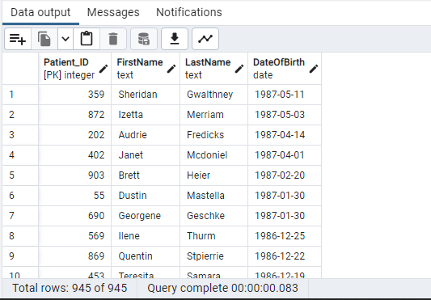

2. Display the firstname and lastname of patients who speaks English language.

Query:

SELECT "FirstName", "LastName","Language"

FROM "Patients" P JOIN "Language" L

ON P."Language_ID" = L."Language_ID"

WHERE "Language" = 'English';

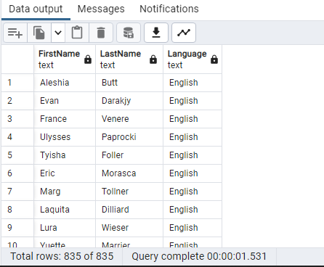

3.Write a query to get list of patient ID's whose PrimaryDiagnosis is 'Flu' ORDER BY patient_ID

Query:

SELECT d."Patient_ID" ,pd."PrimaryDiagnosis" FROM public."Discharges" as d

JOIN public."PrimaryDiagnosis" as pd

ON d."Diagnosis_ID"=pd."Diagnosis_ID" WHERE "PrimaryDiagnosis"='Flu' ORDER BY "Patient_ID";

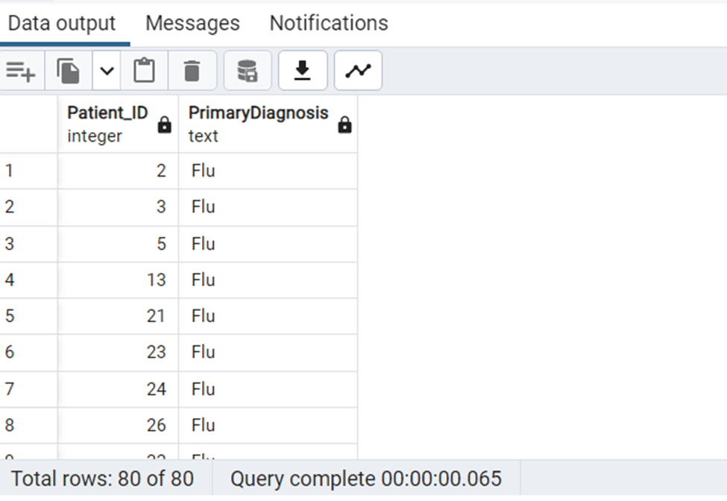

4. Write a query to find the Patient_ID and Admission_ID for the patients whose Primary diaganosis is 'Heart Failure'.

Query:

SELECT d."Patient_ID", d."Admission_ID" ,pd."PrimaryDiagnosis" FROM public."Discharges" as d

JOIN public."PrimaryDiagnosis" as pd

ON d."Diagnosis_ID"=pd."Diagnosis_ID" WHERE "PrimaryDiagnosis"='Heart Failure';

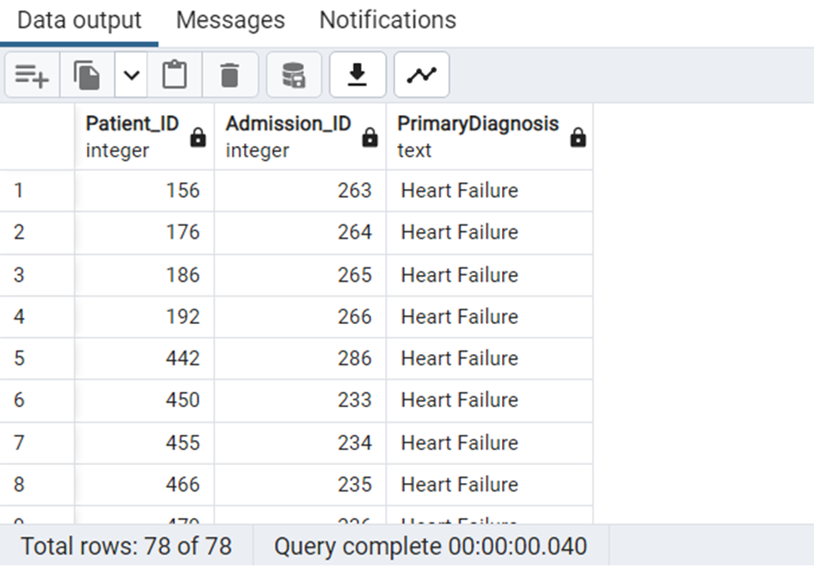

5. Write a query to get list of patient ID's whose pulse is below the normal range.

Query:

SELECT "Patient_ID","Pulse" FROM public."AmbulatoryVisits" WHERE "Pulse" < 60;

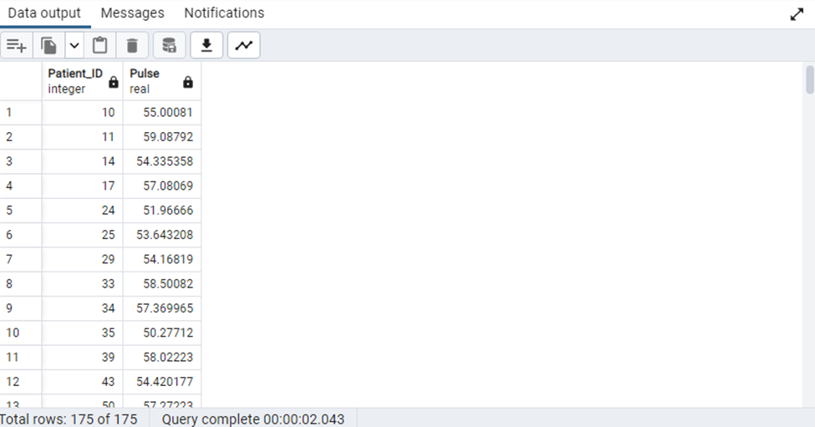

--6. Write a query to find the list of patient_ID's discharged with Service in SID01, SID02, SID03—

Query:

SELECT D."Patient_ID",D."Service_ID"

FROM "Discharges" D

WHERE D."Service_ID" IN ('SID01','SID02','SID03')

--7. Write a query to get list of patients who were admitted because of Stomachache.--

Query:

SELECT P."FirstName" || ' ' || P."LastName" AS PatientName ,"ReasonForVisit"

FROM "Patients" P JOIN "EDVisits" ED ON P."Patient_ID" = ED."Patient_ID"

JOIN "ReasonForVisit" RV ON ED."Rsv_ID" = RV."Rsv_ID"

WHERE RV."ReasonForVisit" = 'Stomach Ache'

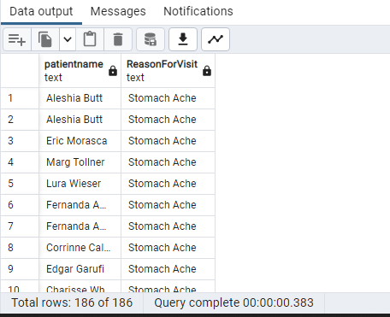

--8. Write a query to Update Service ID SID05 to Ortho--

Query:

UPDATE "Service"

SET "Service" = 'Ortho'

WHERE "Service_ID" = 'SID05'

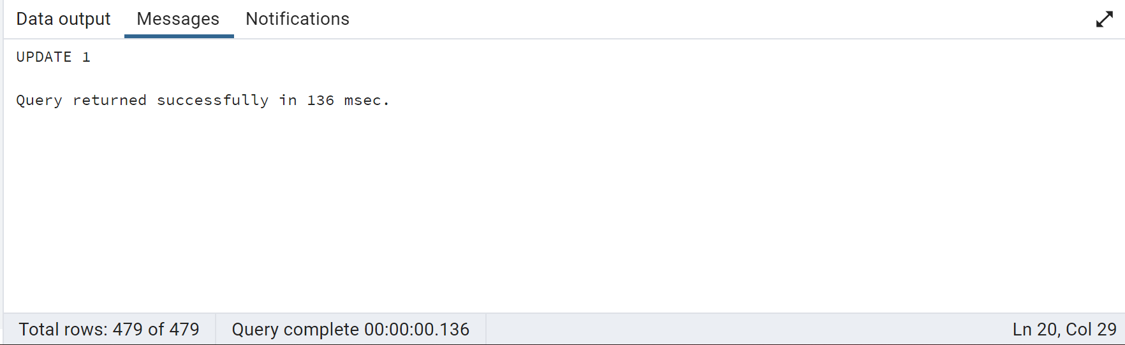

Query:

SELECT * FROM "Service"

--9. Get list of Patient ID's whose visit type was 'Followup' and VisitdepartmentID is 5 or 6--

Query:

SELECT AV."Patient_ID",VT."VisitType",AV."VisitDepartmentID"

FROM "AmbulatoryVisits" AV JOIN "VisitTypes" VT ON AV."AMVT_ID" = VT."AMVT_ID"

WHERE VT."VisitType" = 'Follow Up' AND

(AV."VisitDepartmentID" = 5 OR AV."VisitDepartmentID" = 6)

--10. Create index ONambulatory visit by selecting columns Visit_ID, AMVT_ID and VisitStatus_ID--

Query:

CREATE INDEX ambulatory_visitid_amvtid_visitstatusid_idx

ON "AmbulatoryVisits"("Visit_ID","AMVT_ID","VisitStatus_ID")

-- 11. Create a trigger to execute after inserting a record into Patients table.Insert value to display result.

Query:

-- Creating Temp table to Record Trigger executionTime

CREATE TABLE Audit_Patients(PID Integer NOT NULL PRIMARY KEY,entry_date VARCHAR(100) NOT NULL)

--Creating Trigger Function

CREATE OR REPLACE FUNCTION auditlogfunc()

RETURNS TRIGGER AS $examp_table$

BEGIN

INSERT INTO audit_patients(pid,entry_date) VALUES(NEW."Patient_ID",CURRENT_TIMESTAMP);

RETURN NEW;

END;

$examp_table$ LANGUAGE plpgsql;

--Creating Trigger

CREATE TRIGGER patient_trigger AFTER INSERT ON public."Patients" FOR EACH ROW

EXECUTE PROCEDURE auditlogfunc()

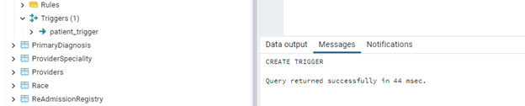

--Testing By Inserting records into Patients

INSERT into "Patients"("Patient_ID","FirstName","LastName") VALUES ('946','KKK','LLL')

--Checking for Newly added record

SELECT * FROM public."Patients" ORDER BY "Patient_ID" DESC LIMIT 5

--Checking Trigger Log

SELECT * FROM public.audit_patients

--After inserting records Into Patients, trigger is executed and created record in Log table “audit_patients”

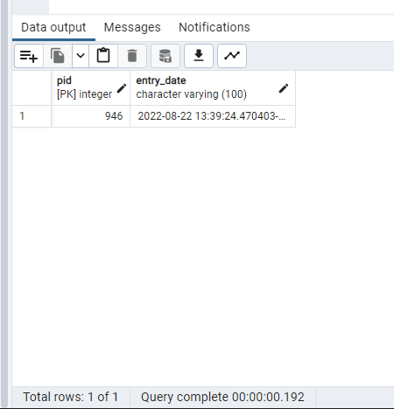

-- 12.Write a query to find the ProviderName and Provider Speciality for PS_ID ='PSID02'

Query:

SELECT PV."ProviderName" ProviderName,PS."ProviderSpeciality",PS."PS_ID"

FROM "ProviderSpeciality" PS JOIN "Providers" PV

ON PV."PS_ID" = PS."PS_ID"

WHERE PV."PS_ID"='PSID02'

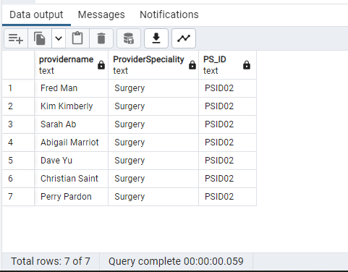

-- 13. Display the patient names and ages whose age is more than 50 years

Query:

SELECT "FirstName","Patients"."LastName",date_part('year',age("Patients"."DateOfBirth")) as Age

FROM "Patients" WHERE (date_part('year',age("Patients"."DateOfBirth"))) >50

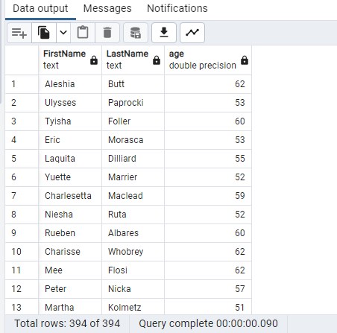

-- 14.Write a query to get list of patient ID's and service whose are in service as 'Neurology'

Query:

SELECT RG."Patient_ID",S."Service" FROM "ReAdmissionRegistry" RG JOIN "Service" AS S

ON RG."Service_ID" = S."Service_ID"

WHERE "Service" = 'Neurology'

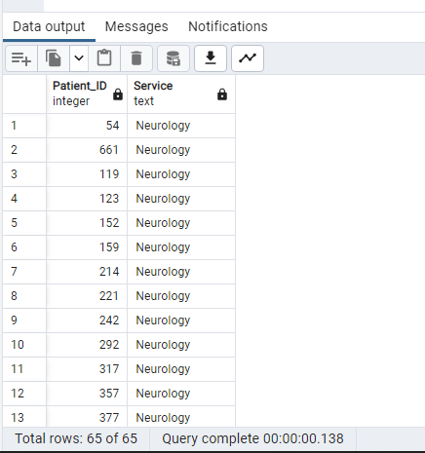

-- 15.Create view ONtable Provider table ONcolumns ProviderName and Provider_ID

Query:

CREATE VIEW View_Provider("ProviderName","Provider_ID")

AS

SELECT "ProviderName","Provider_ID" FROM "Providers"

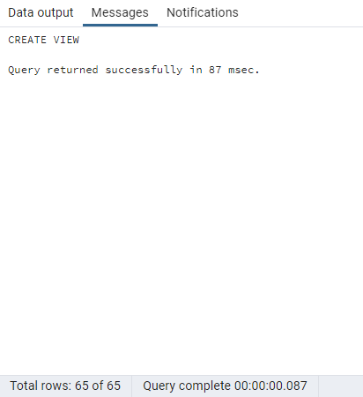

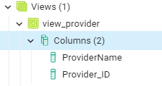

SELECT * FROM public.view_provider

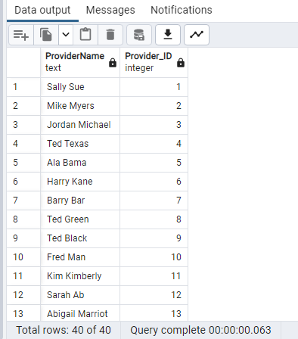

--16. Write a query to Extract Year FROM ProviderDateOnStaf

Query:

SELECT to_char("ProviderDateOnStaff",'YYYY') as "ProviderYearOnStaff"

FROM public."Providers"

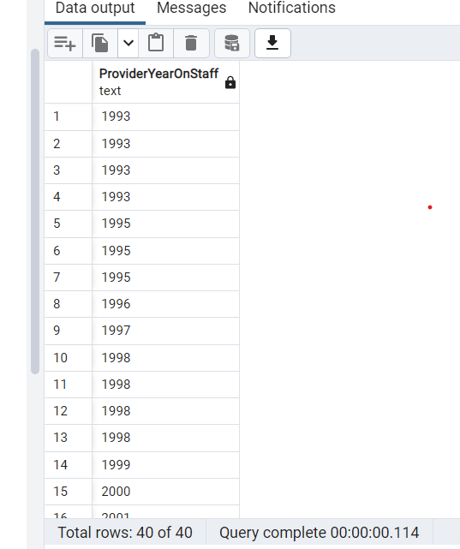

--17. Write a query to get unique Patient_ID,race and Language of patients

whose race is White and also speak English.

Query:

SELECT Distinct("Patient_ID"),"Race","Language"

FROM public."Patients" as Pt

JOIN public."Race" as R

ON Pt."Race_ID" = R."Race_ID"

JOIN public."Language" as L

ON Pt."Language_ID" = L."Language_ID"

WHERE 1=1

And R."Race" = 'White'

And L."Language" = 'English'

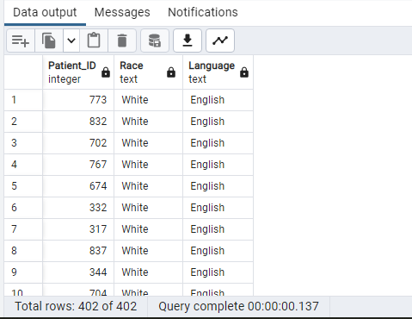

--Q18. Get list of patient ID's whose service was 'Cardiology' and discharged to

'Home'

Query:

SELECT "Patient_ID","Service","DischargeDisposition"

FROM "ReAdmissionRegistry" RA JOIN "DischargeDisposition" DD

ON RA."Discharge_ID"= DD."Discharge_ID"

JOIN "Service" S

ON RA."Service_ID" = S."Service_ID"

WHERE DD."DischargeDisposition" = 'Home'

AND S."Service"='Cardiology'

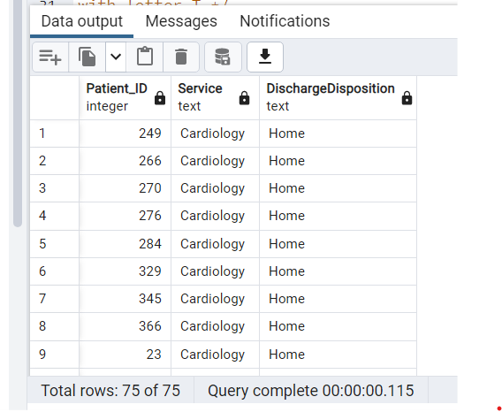

--Q19. Write a query to get list of Provider names whose Providername is starting

with letter

Query:

SELECT "ProviderName" FROM public."Providers"

WHERE "ProviderName" like 'T%'

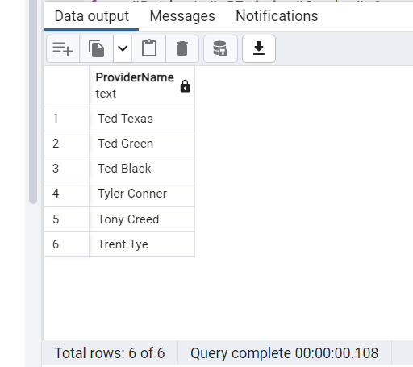

--Q20. List female patients over the age of 40 who have undergone surgery from

January-March 2019

Query:

SELECT "FirstName" || ' ' || "LastName" as "PatientName"

,substring(G."Gender",1,1) as "Gender"

, EXTRACT(YEAR FROM AGE(CURRENT_DATE, Pt."DateOfBirth")) as "Age"

, AV."DateofVisit"

FROM "Patients" PT JOIN "Gender" G

ON PT."Gender_ID" = G."Gender_ID"

JOIN "AmbulatoryVisits" AV

ON PT."Patient_ID" = AV."Patient_ID"

JOIN "Providers" P

ON P."Provider_ID" = AV."Provider_ID"

JOIN "ProviderSpeciality" PS

ON PS."PS_ID"= P."PS_ID"

WHERE

G."Gender" = 'Female' AND

EXTRACT(YEAR FROM AGE(CURRENT_DATE, Pt."DateOfBirth")) > 40 AND

PS."ProviderSpeciality" = 'Surgery' AND

AV."DateofVisit" between to_date('20190101','YYYYMMDD') AND to_date('20190331','YYYYMMDD')

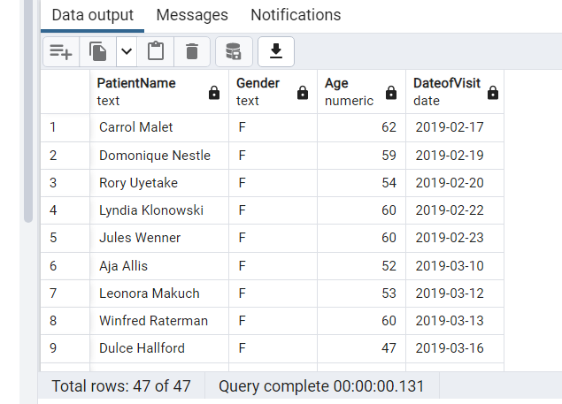

--21. Write a Query to get list of Male patients.--

Query:

SELECT p."FirstName",p."LastName",g."Gender" FROM public."Patients" as p

JOIN public."Gender" as g

ON p."Gender_ID"= g."Gender_ID" WHERE g."Gender"='Male';

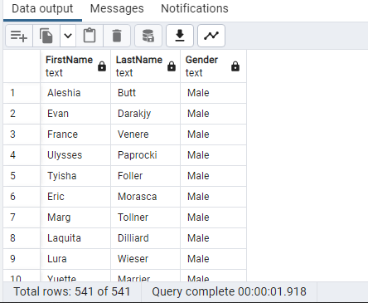

--22. Write a query to get list of patient ID's who has discharged to home--

Query:

SELECT "Patient_ID" FROM public."Discharges" as d

JOIN public."DischargeDisposition" as dd

ON d."Discharge_ID"= dd."Discharge_ID"

WHERE dd."DischargeDisposition"='Home';

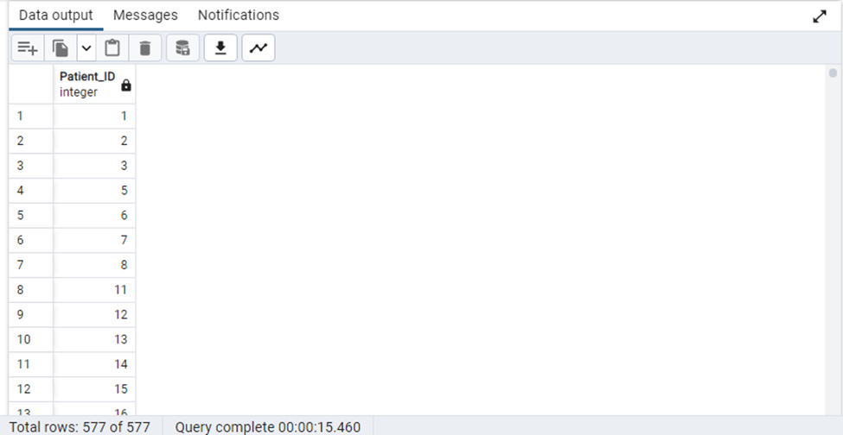

--23. Find the category of illness(Stomach Ache or Migraine) that has maximum

number of patients--

Query:

SELECT COUNT(edv."Patient_ID") AS P_Count,rfv."ReasonForVisit" FROM public."EDVisits" as edv

JOIN public."ReasonForVisit" as rfv ONedv."Rsv_ID"=rfv."Rsv_ID"

WHERE "ReasonForVisit"='Stomach Ache' OR "ReasonForVisit"='Migraine'

GROUP BY rfv."ReasonForVisit" ORDER BY P_Count DESC LIMIT 1

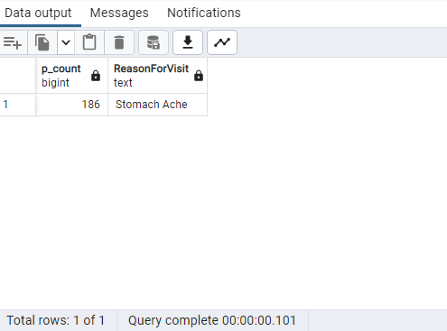

--24. Write a query to get list of New Patient ID's.—

Query:

SELECT av."Patient_ID" FROM public."AmbulatoryVisits" as av

JOIN public."VisitTypes" as vt

ON av."AMVT_ID"= vt."AMVT_ID"

WHERE vt."VisitType"='New';

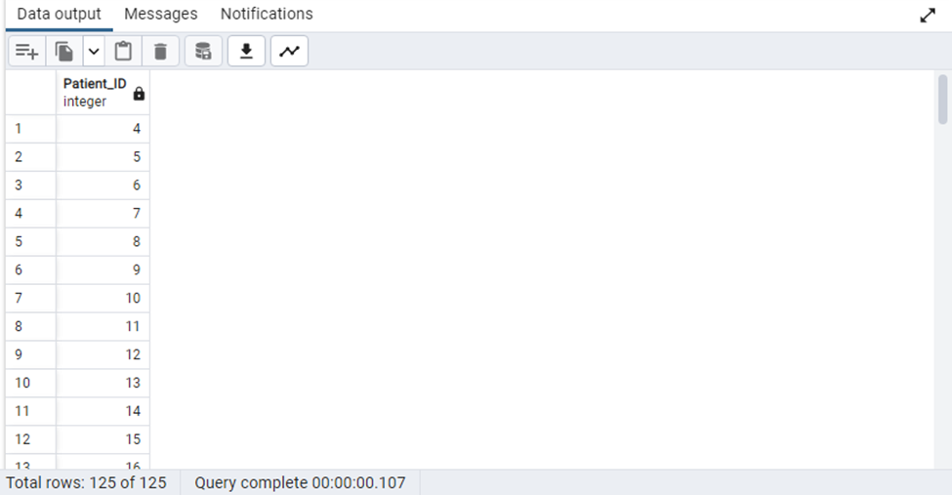

--25. Create trigger on table Readmission registry—

Query:

SELECT * FROM public."ReAdmissionRegistry"

INSERT INTO "ReAdmissionRegistry" VALUES (1000,1000,'2018-05-26','2018-05-26 20:40:34','DID01','SID01','PD001','12','0.23',1,3,1)

--creating temporary table--

CREATE TABLE temp_readm(

"Entry_Date" VARCHAR(100) NOT NULL

)

--creating Trigger Function--

CREATE OR REPLACE FUNCTION Del()

RETURNS TRIGGER AS $NEW$

BEGIN

INSERT INTO temp_readm("Entry_Date")

VALUES(CURRENT_TIMESTAMP);

RETURN NEW;

END;

$NEW$ LANGUAGE plpgsql;

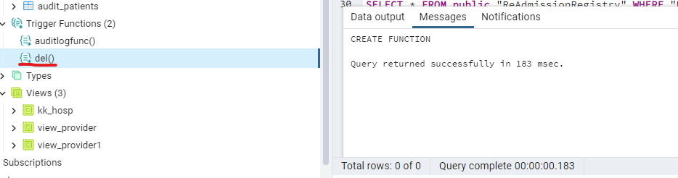

--creating trigger named Trigger_readm--

CREATE TRIGGER Trigger_readm

AFTER DELETE ON "ReAdmissionRegistry"

FOR EACH ROW

EXECUTE PROCEDURE Del();

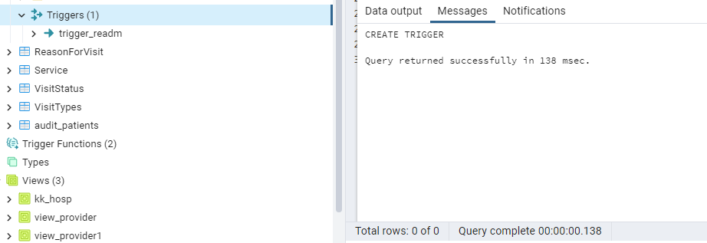

--Deleting a Record From ReAdmissionRegistry to execute Trigger

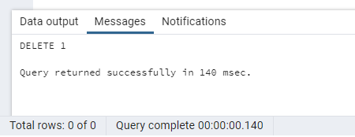

--Temp Table got updated with the time the record got deleted

SELECT * FROM temp_readm

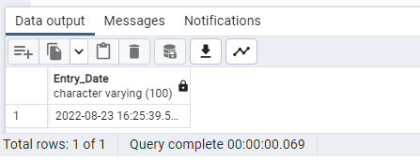

----26. Select all providers with a name starting 'h' followed by any character ,

--followed by 'r', followed by any character, followed by 'y

Query:

SELECT "ProviderName"

FROM "Providers"

WHERE "ProviderName" LIKE 'H_r_y%'

--27. Show the list of the patients who have cancelled their appointment--

Query:

SELECT P."FirstName" || ' ' || P."LastName" AS PatientName ,"VisitStatus"

FROM "Patients" P

JOIN "AmbulatoryVisits" AV ON P."Patient_ID" = AV."Patient_ID"

JOIN "VisitStatus" VS ON AV."VisitStatus_ID" = VS."VisitStatus_ID"

WHERE VS."VisitStatus" = 'Canceled'

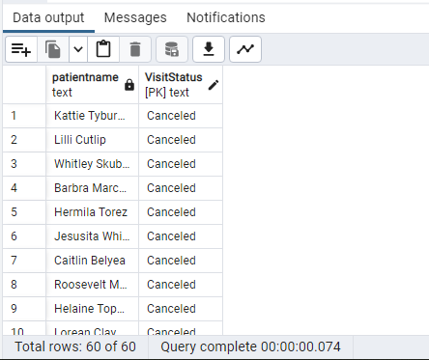

--28. Write a query to get list of ProviderName's with a name starting 'ted--

Query:

SELECT "ProviderName"

FROM "Providers"

WHERE "ProviderName" LIKE 'Ted%'

--29. Create a view without using any schema or table and check the created view using SELECT statement--

Query:

CREATE VIEW BPLimit_view AS

SELECT text 'BPS>130 & BPD>80' AS High_BP,

text 'BPS<90 & BPD<60' AS Low_BP

//View created ONBP Limits without using table or schema. //

Query:

SELECT * FROM BPLimit_view

--30. Write a query to get unique list of Patient Id's whose reason for visit is car accident--

Query:

SELECT DISTINCT P."Patient_ID","ReasonForVisit"

FROM "Patients" P

INNER JOIN "EDVisits" ED ON P."Patient_ID" = ED."Patient_ID"

INNER JOIN "ReasonForVisit" RV ON ED."Rsv_ID" = RV."Rsv_ID"

WHERE RV."ReasonForVisit" = 'Car Accident'

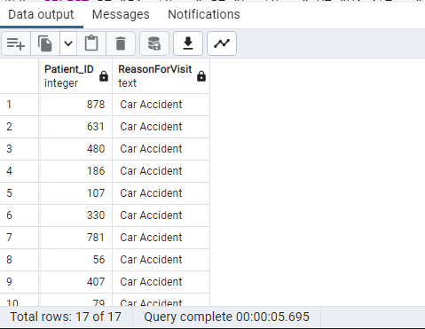

--31. Find which Visit type of patients are maximum in cancelling their appointment

Query:

SELECT COUNT("Patient_ID") AS PVType_Count,"VisitType"

FROM "AmbulatoryVisits" AV JOIN "VisitTypes" V

ON AV."AMVT_ID" = V."AMVT_ID" JOIN "VisitStatus" VS ON AV."VisitStatus_ID" = VS."VisitStatus_ID"

WHERE "VisitStatus"='Canceled' GROUP BY "VisitType" ORDER BY PVType_Count DESC LIMIT 1

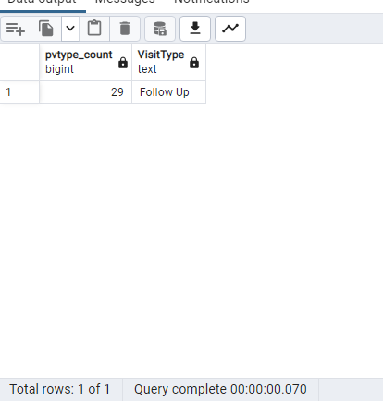

-- 32. Write a query to Count number of patients by VisitdepartmentID WHERE count greater than 50

Query:

SELECT "VisitDepartmentID",count("Patient_ID") as "Patient_Count" FROM "AmbulatoryVisits"

GROUP BY("VisitDepartmentID") HAVING count("Patient_ID")> 50

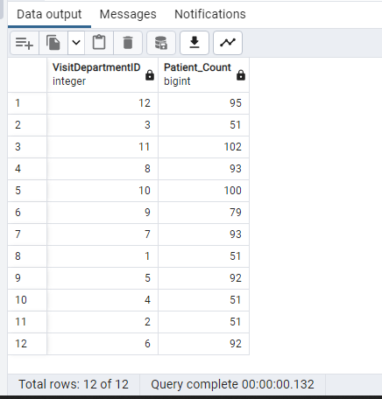

-- 33. Write a query to get list of patient names whose visit type is new and visitdepartmentId is 2

Query:

SELECT PT."FirstName",PT."LastName",VT."VisitType",AV."VisitDepartmentID" FROM "Patients" PT

JOIN "AmbulatoryVisits" AV ON PT."Patient_ID" = AV."Patient_ID"

JOIN "VisitTypes" VT ON VT."AMVT_ID" = AV."AMVT_ID"

WHERE "VisitDepartmentID" = 2 AND "VisitType"='New'

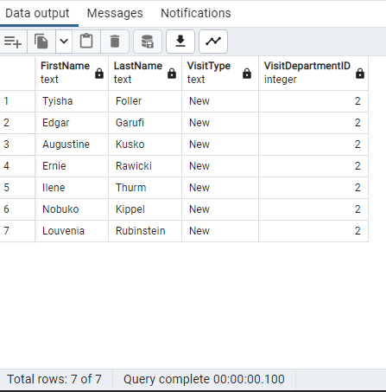

-- 34. Write a query to find the most commONreasons for hospital visit for patients between 50 and 60 years

Query:

SELECT "ReasonForVisit" ,COUNT(P."Patient_ID") AS Patient_Count

FROM "Patients" P JOIN "EDVisits" EV ON EV."Patient_ID" = P."Patient_ID"

JOIN "ReasonForVisit" ON "ReasonForVisit"."Rsv_ID" = EV."Rsv_ID"

WHERE date_part('year',age(P."DateOfBirth")) BETWEEN 50 AND 60

GROUP BY "ReasonForVisit" ORDER BY Patient_Count DESC

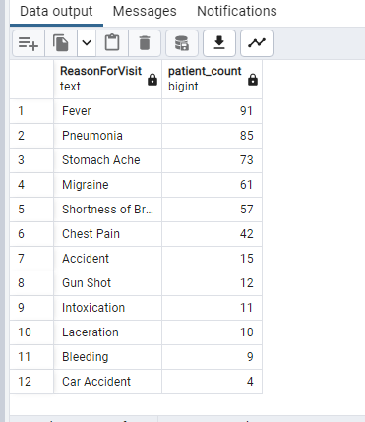

-- 35. Get list of Patients whose gender is Male and who speak English and whose race is White

Query:

SELECT P."FirstName",P."LastName","Gender","Language","Race"

FROM "Patients" P JOIN "Gender" G ON G."Gender_ID" = P."Gender_ID"

JOIN "Language" L ON L."Language_ID" = P."Language_ID"

JOIN "Race" R ON R."Race_ID" = P."Race_ID"

Where (G."Gender"='Male' AND L."Language" = 'English' AND R."Race" ='White')

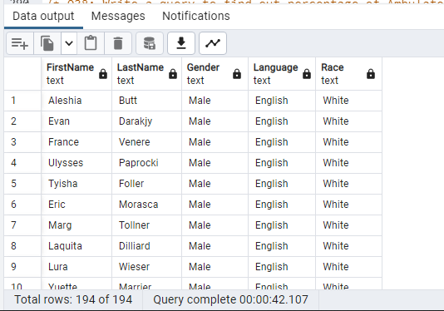

--Q36: Create index ONPatient table

Query:

CREATE index "FirstNameIndex" ON"Patients"("FirstName")

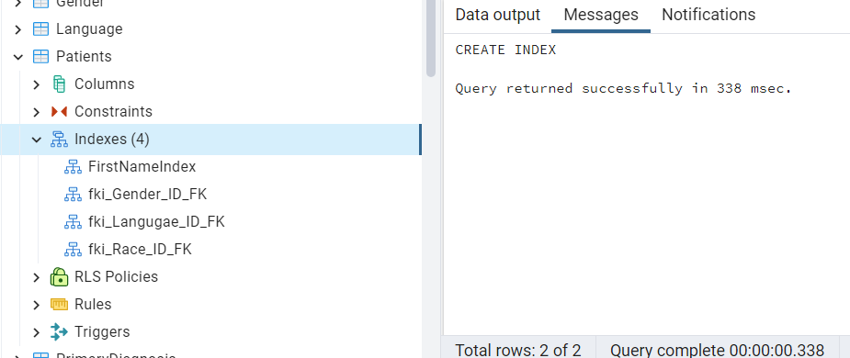

--Q37: Write a query to get list of Provider ID's WHERE ProviderDateOnStaff year is

2013 and 2010

Query:

SELECT "Provider_ID", to_char("ProviderDateOnStaff",'YYYY') as "ProviderDateOnStaffYear"

FROM "Providers"

WHERE to_char("ProviderDateOnStaff",'YYYY') in('2013','2010')

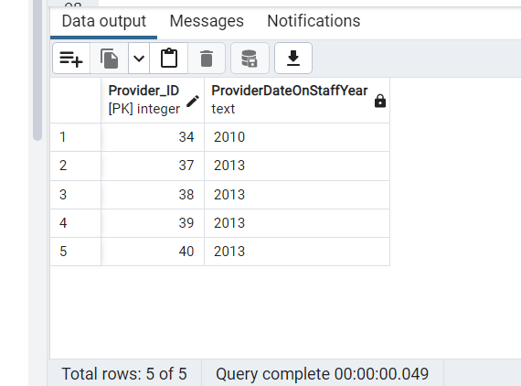

--Q38: Write a query to find out percentage of Ambulatory visits by visit type.*/

//Using sub query

Query:

SELECT VT."VisitType" as "Visit_Type"

,count(AV."Visit_ID") "Visit_Count"

,(SELECT count("Visit_ID") FROM "AmbulatoryVisits") "Total_Count"

,round(count(AV."Visit_ID")*100.0/(SELECT count("Visit_ID") FROM "AmbulatoryVisits"),2) as "Visit_Percentage"

FROM "AmbulatoryVisits" AV

JOIN "VisitTypes" VT

ON AV."AMVT_ID" = VT."AMVT_ID"

Group By "VisitType"

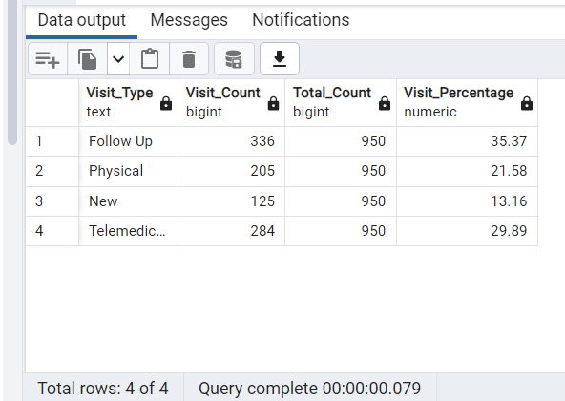

--Q39: Write a query to get list of patient names who has discharged.

Query:

SELECT "FirstName" || ' ' || "LastName" as "DischargedPatientName" ,"DischargeDisposition"

FROM "Patients" PT JOIN "Discharges" D

ON PT."Patient_ID" = D."Patient_ID"

JOIN "DischargeDisposition" DD

ON DD."Discharge_ID" = D."Discharge_ID"

WHERE DD."DischargeDisposition" = 'Home'

ORDER BY "DischargedPatientName"

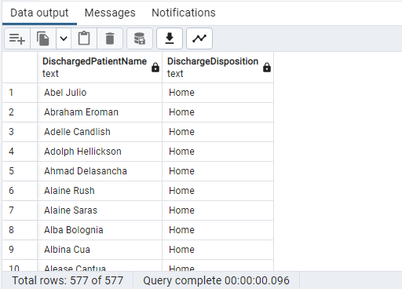

.

--Q40: Create view on table EdVisit by selecting some columns and filter data

using Where condition

Query:

Create View "EDVisitView" as

SELECT "EDVisit_ID", "Patient_ID", "Acuity"

FROM "EDVisits"

WHERE "Acuity" = 3

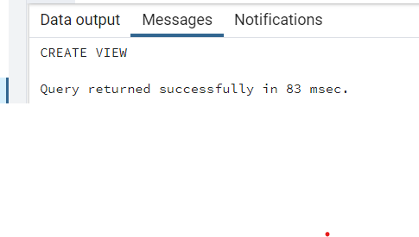

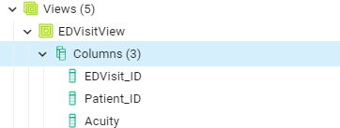

SELECT * FROM "EDVisitView"

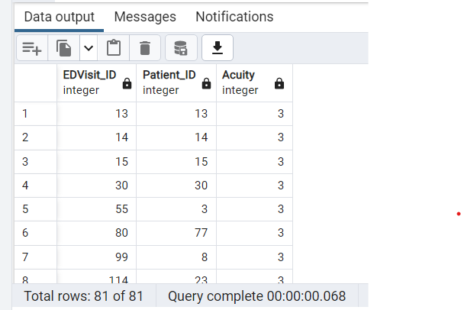

--41. Get list of patient names whose primary diagnosis as 'Spinal Cord injury'

having Expected LOS is greater than 15--

Query:

SELECT p."FirstName",p."LastName",pd."PrimaryDiagnosis",rr."ExpectedLOS"

FROM public."Patients" as p

JOIN public."ReAdmissionRegistry" as rr

ON p."Patient_ID"=rr."Patient_ID"

inner JOIN public."PrimaryDiagnosis" as pd

ON rr."Diagnosis_ID"=pd."Diagnosis_ID" WHERE pd."PrimaryDiagnosis"='Spinal Cord Injury'

AND rr."ExpectedLOS" >'15';

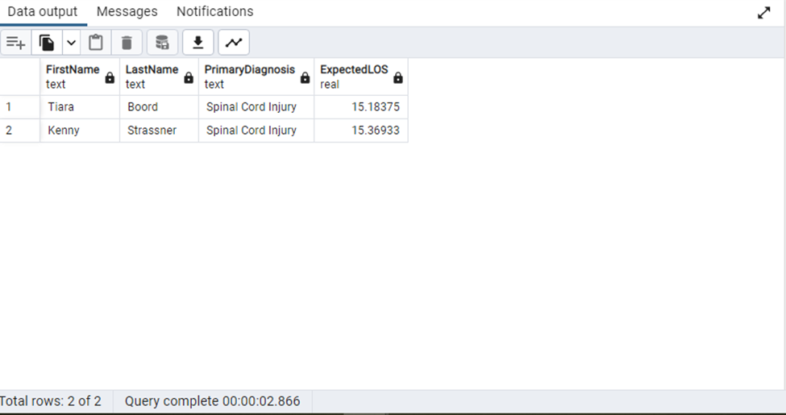

--42. Write a query to get list of Patient names who haven't discharged—

Query:

SELECT p."FirstName",p."LastName",dd."DischargeDisposition" FROM public."Patients" as p

JOIN public."Discharges" as d ON d."Patient_ID"=p."Patient_ID"

JOIN public."DischargeDisposition" as dd ON d."Discharge_ID"= dd."Discharge_ID"

WHERE dd."DischargeDisposition"='Transfer';

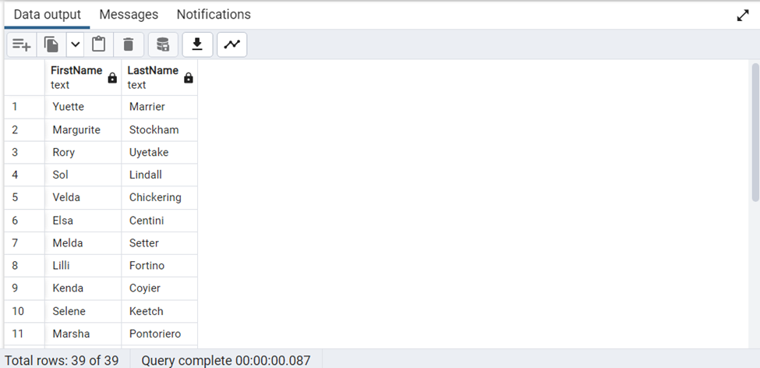

--43. Write a query to get list of Provider names whose ProviderSpecialty is Pediatrics.--

Query:

SELECT p."ProviderName",ps."ProviderSpeciality" FROM public."Providers" as p

JOIN public."ProviderSpeciality" as ps ON p."PS_ID"=ps."PS_ID"

WHERE ps."ProviderSpeciality"='Pediatrics';

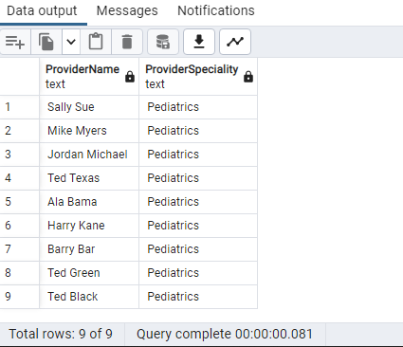

--44. Write a query to get list of patient ID's who has admitted ON1/7/2018 and

discharged on 1/15/2018--

Query:

SELECT d."Patient_ID",d."AdmissionDate", cast(d."DischargeDate" as date )

FROM public."Discharges" as d

WHERE d."AdmissionDate" = '2018-01-07' and cast (d."DischargeDate" as date) = '2018-01-15 ' ;

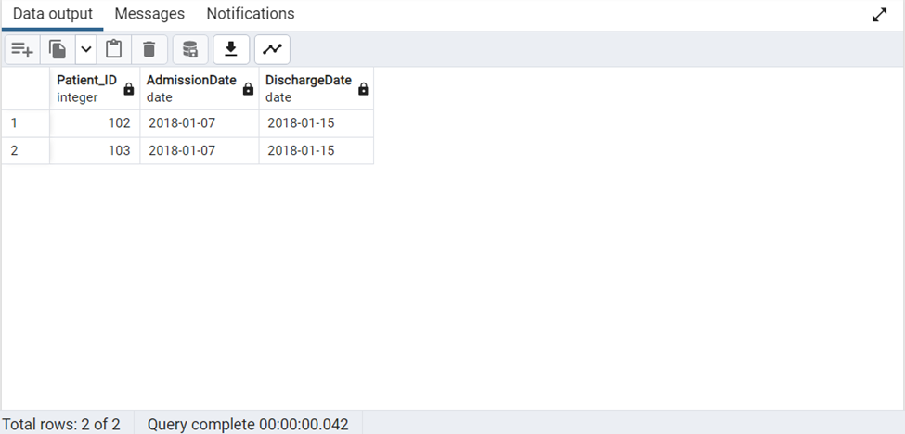

--45. Write a query to find outpatients vs inpatients by monthwise (hint:

consider readmission/discharges and ambulatory visits table for inpatients

and outpatients)—

Query:

- CREATE extension tablefunc;

SELECT * FROM

CROSSTAB(

$$

with cte as

(

SELECT count(av."Patient_ID") counts,

to_char(av."DateofVisit",'month')mns,date_part('year',av."DateofVisit")yrs,

'outpatients' typ

FROM public."AmbulatoryVisits" av

GROUP BY mns,yrs

UNION ALL

SELECT count(rr."Patient_ID") counts,

to_char(rr."AdmissionDate",'month') mns,date_part('year',rr."AdmissionDate")yrs,

'inpatients' typ

FROM public."ReAdmissionRegistry" rr

GROUP BY mns,yrs )

SELECT mns,yrs,typ,counts FROM

cte $$,

$$ values

( 'inpatients' ),

('outpatients')

$$)

AS (

mns text,

yrs numeric,

inpatients numeric,

outpatients numeric

) ;

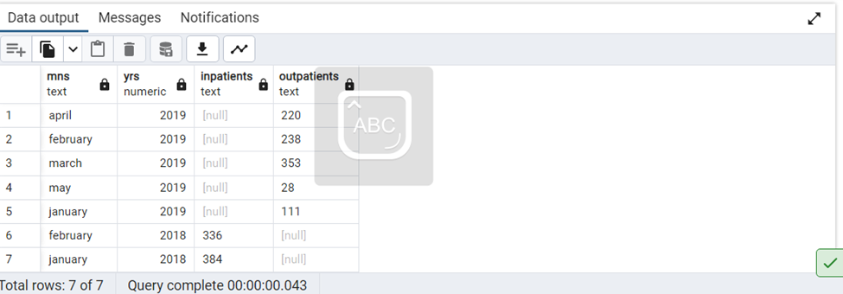

Note: Created a Common Table Expression(CTE) for Pivoting the table.

Used Create extension tablefunc for table function crosstab.

Used CROSSTAB Function for pivoting the table columns.

--46. Write a query to get list of Number of Ambulatory Visits by --

--Provider Speciality per month--

Query:

SELECT COUNT(AV."Visit_ID")AS NumberOfAmbulatoryVisits,PS."ProviderSpeciality",

TO_CHAR(AV."DateofVisit",'Month') AS Month,EXTRACT(year FROM AV."DateofVisit") AS Year

FROM (("AmbulatoryVisits" AV

JOIN "Providers" PR ON AV."Provider_ID" = PR."Provider_ID")

JOIN "ProviderSpeciality" PS ON PR."PS_ID" = PS."PS_ID")

GROUP BY PS."ProviderSpeciality",Month,Year

ORDER BY PS."ProviderSpeciality",Month,Year

--47.Write a query to find Average age for admissiONby service--

Query:

SELECT ROUND(AVG(EXTRACT('year' FROM AGE(P."DateOfBirth")))) AS Average_Age, S."Service"

FROM (("Patients" P

JOIN "Discharges" D ON P."Patient_ID" = D."Patient_ID" )

JOIN "Service" S ON D."Service_ID" = S."Service_ID")

GROUP BY S."Service"

--48. Write a query to get list of patient with their full names whose names contains "Ma"--

Query:

SELECT P."FirstName" || ' ' || P."LastName" AS PatientName

FROM "Patients" P

WHERE (P."FirstName" LIKE 'Ma%' OR P."FirstName" LIKE '%Ma') OR

(P."LastName" LIKE 'Ma%' OR P."LastName" LIKE '%Ma')

--49. Update Visit Timestamp column in EDVisits table by selecting data type as--

--timestamp with timezone--

Query:

ALTER TABLE "EDVisits"

ALTER COLUMN "VisitTimestamp"

SET DATA TYPE timestamptz

--50. Create a trigger function on AmbulatoryVisits by selecting any two columns.--

--creating temporary table--

Query:

CREATE TABLE ambupdate(

"Pat_ID" INTEGER NOT NULL,

"VisitDate" DATE,

"ScheduledDate" TIMESTAMP

)

//Creating a table ambupdate, containing three columns Patient ID, VisitDateD and Scheduled date. This table gets updated, whenever DateofVisit and DateScheduled FROM AmbulatoryVisits gets updated.//

TRIGGER ON UPDATE

--creating Trigger Function--

CREATE OR REPLACE FUNCTION update()

RETURNS TRIGGER AS $NEW$

BEGIN

INSERT INTO ambupdate("Pat_ID","VisitDate","ScheduledDate")

VALUES(NEW."Patient_ID",NEW."DateofVisit",NEW."DateScheduled");

RETURN NEW;

END;

$NEW$ LANGUAGE plpgsql;

//update() is the trigger functiONcreated.//

--creating trigger named update_ambulatory--

CREATE TRIGGER update_ambulatory

AFTER UPDATE ON "AmbulatoryVisits"

FOR EACH ROW

EXECUTE PROCEDURE update();

//Whenever the DateofVisit and DateScheduled FROM AmbulatoryVisits table gets updated, trigger update_ambulatory calls ONtrigger functiONupdate() to insert the updated column values into temp table ambupdate.//

--update--

UPDATE "AmbulatoryVisits"

SET "DateofVisit" = '2019-01-15' , "DateScheduled" = '2018-12-30 9:18:24'

WHERE "Patient_ID" = 5

//Screenshot of trigger and trigger function.//

//Screenshot of table ambupdate with the updated record.//

-- 51. Insert number of days for ReadmissiONin DaysToReadmissiONColumn for patient ID's FROM 737 to 742

QUERY :

UPDATE "ReAdmissionRegistry" SET "DaysToReadmission" ='6' WHERE "Patient_ID" ='737'

UPDATE "ReAdmissionRegistry" SET "DaysToReadmission" ='8' WHERE "Patient_ID" ='738'

UPDATE "ReAdmissionRegistry" SET "DaysToReadmission" ='9' WHERE "Patient_ID" ='739'

UPDATE "ReAdmissionRegistry" SET "DaysToReadmission" ='10' WHERE "Patient_ID" ='740'

UPDATE "ReAdmissionRegistry" SET "DaysToReadmission" ='11' WHERE "Patient_ID" ='741'

UPDATE "ReAdmissionRegistry" SET "DaysToReadmission" ='12' WHERE "Patient_ID" ='742'

//Checking the Updated Records

SELECT "Patient_ID","DaysToReadmission" FROM public."ReAdmissionRegistry" WHERE "Patient_ID" BETWEEN '737' and '742'

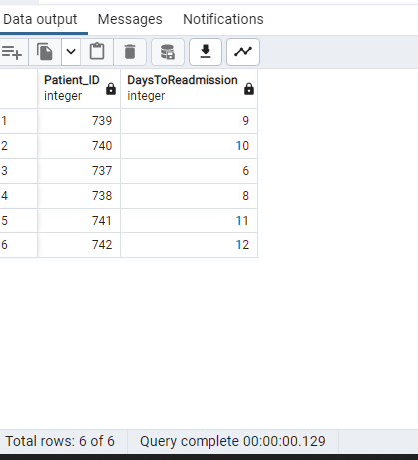

-- 52. Get list of Provider names whose name is starting with K and ending with y(Hint:K-Upper, Y-Lower)

Query :

SELECT "ProviderName" FROM "Providers" WHERE "ProviderName" LIKE 'K%y'

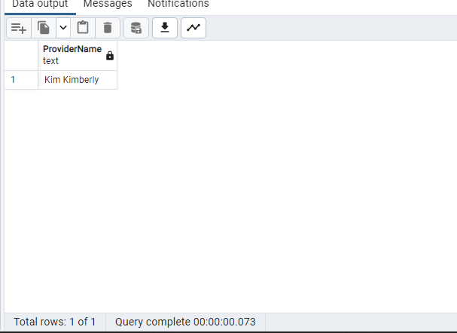

-- 53. Write a query to Split provider First name and Last name into different column

Query :

SELECT "Providers"."ProviderName",SPLIT_PART("ProviderName",' ',1) AS "First name" , SPLIT_PART("ProviderName",' ',2) AS "Last name" FROM "Providers"

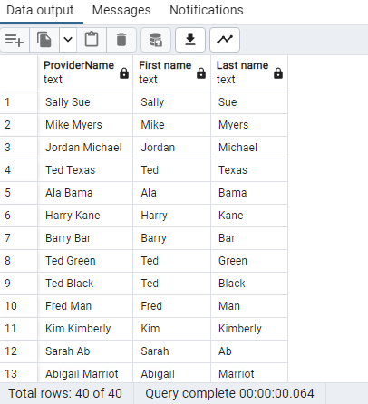

-- 54. Get list of Patient ID's ORDER BY Discharge date

Query:

SELECT "Patient_ID","DischargeDate" FROM "Discharges" ORDER BY "DischargeDate"

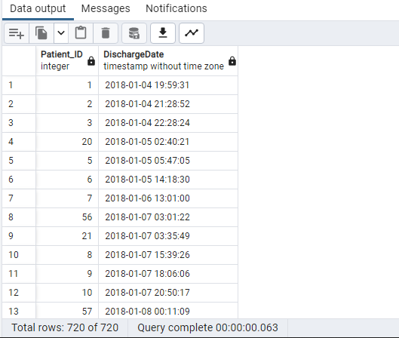

-- 55. Write a query to drop View by creating view ONtable Discharge by selecting columns

//Created View View_Discharges

CREATE VIEW View_Discharges("ExpectedLOS","Discharge_ID")

AS

SELECT "ExpectedLOS","Discharge_ID" FROM "Discharges"

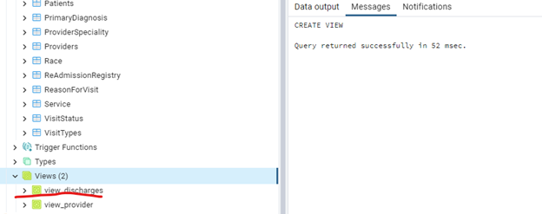

//Dropping View

DROP VIEW view_discharges

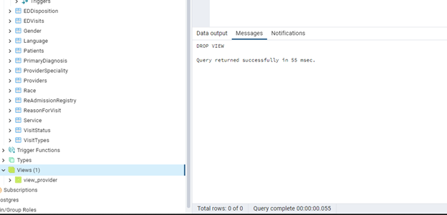

--Q56: Write a query to get list of Patient ID's WHERE Visitdepartment ID is 1 and

BloodPressureSystolic is between 123 to 133 */

Query:

SELECT PT."Patient_ID", AV."VisitDepartmentID", AV."BloodPressureSystolic"

FROM "Patients" PT JOIN "AmbulatoryVisits" AV

ON PT."Patient_ID"= AV."Patient_ID"

where

"VisitDepartmentID" = 1

And

AV."BloodPressureSystolic" between 123 And 133

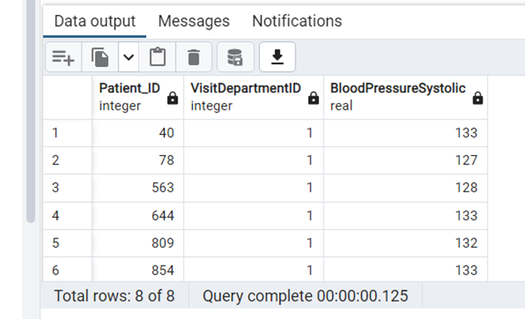

--Q57: Write the query to CREATE Index ONtable ReasonForVisit by selecting a

column and also write the query drop same index*/

Query :

CREATE Index "ReasonForVisitIndex" ON"ReasonForVisit"("ReasonForVisit")

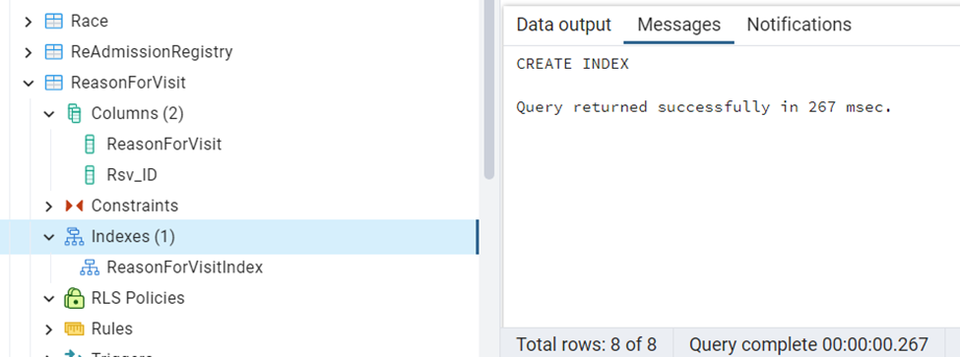

// Query to drop the index

DROP INDEX "ReasonForVisitIndex"

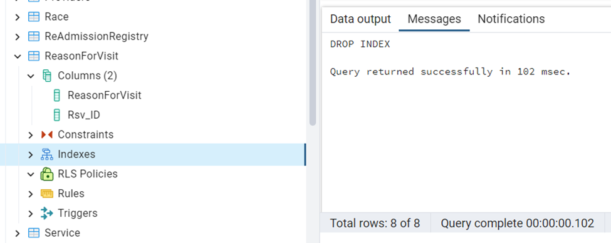

--Q58: Write a query to Count number of unique patients EDDispositiONwise.*/

Query:

SELECT EDD."EDDisposition", count(distinct("Patient_ID")) as "UniqueCountOfPatients"

FROM "EDVisits" EDV JOIN "EDDisposition" EDD

ON EDV."EDD_ID"= EDD."EDD_ID"

group by EDD."EDDisposition"

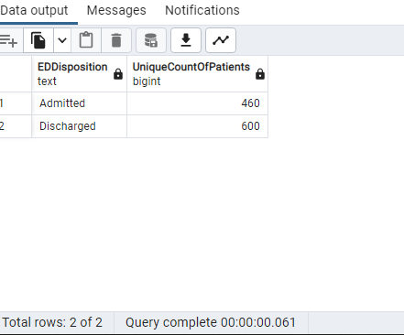

--Q59: Write a query to get list of Patient ID's WHERE Visitdepartment ID is 5 or

BloodPressureSystolic is NOT NULL

Query:

SELECT PT."Patient_ID", AV."VisitDepartmentID", AV."BloodPressureSystolic"

FROM "AmbulatoryVisits" AV JOIN "Patients" PT

ON PT."Patient_ID" = AV."Patient_ID"

WHERE

AV."VisitDepartmentID" = 5

OR

AV."BloodPressureSystolic" IS NOT NULL

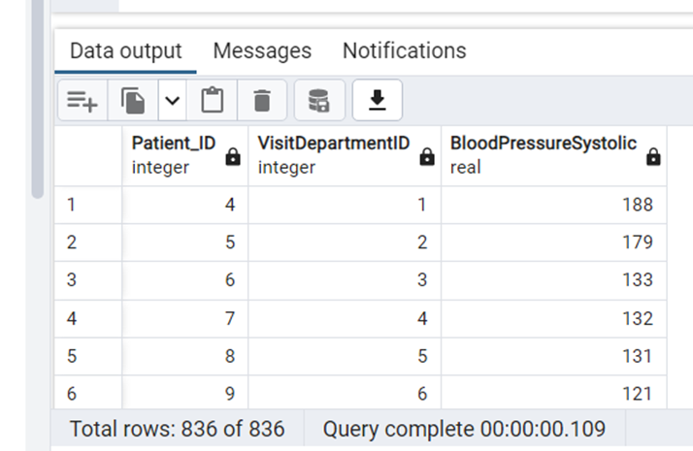

--Q60: Query to find the number of patients readmitted by Service

Query:

SELECT S."Service", count(RA."Patient_ID") as "No.OfPatients"

FROM "Service" S JOIN "ReAdmissionRegistry" RA

ON S."Service_ID" = RA."Service_ID"

group by "Service"

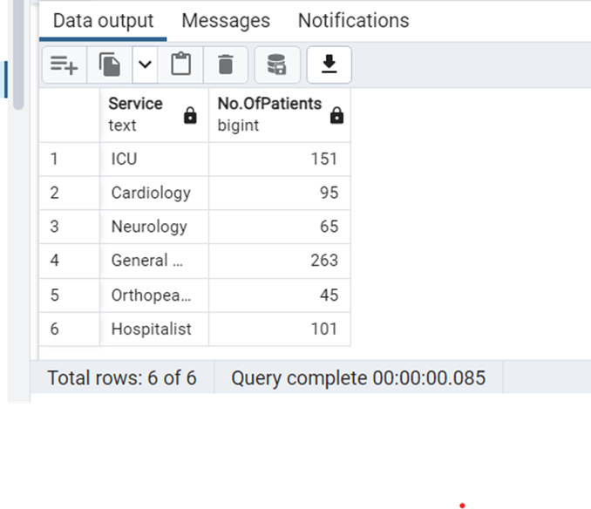

--61. Write a query to list male patient ids and their names who are above 40

years of age and less than 60 years and have BloodPressureSystolic above

120 and BloodPressureDiastolic above 80--

Query:

SELECT p."Patient_ID",p."FirstName",p."LastName",

date_part('year',age("DateOfBirth")) as Patient_Age , "Gender" , "BloodPressureSystolic","BloodPressureDiastolic"

FROM public."Patients" as p

JOIN public."Gender" as g

ON p."Gender_ID"= g."Gender_ID"

JOIN public."AmbulatoryVisits" as av

ON p."Patient_ID"=av."Patient_ID"

WHERE g."Gender"='Male' and

av."BloodPressureSystolic">'120' and av."BloodPressureDiastolic">'80' and

date_part('year',age("DateOfBirth")) between 40 and 60 ;

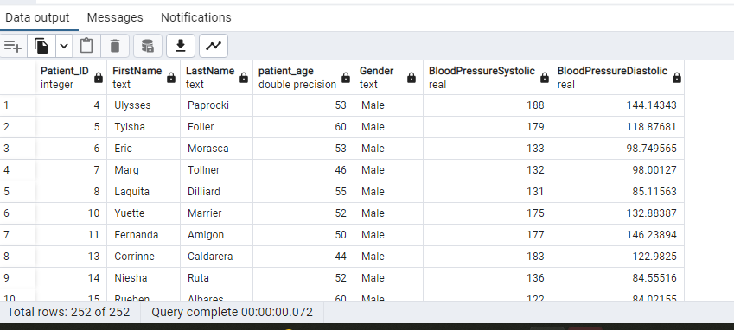

--62. Query to find the number of outpatients who have visited month wise(use month names)--

Query:

select count(p."Patient_ID") AS OutPatients_Count,to_char(av."DateofVisit",'month') month_visit,date_part('year',av."DateofVisit") year_visit

FROM public."Patients" p

inner JOIN public."AmbulatoryVisits" av

ON p."Patient_ID"= av."Patient_ID"

group by to_char(av."DateofVisit",'month'), date_part('year',av."DateofVisit")

ORDER BY to_char(av."DateofVisit",'month');

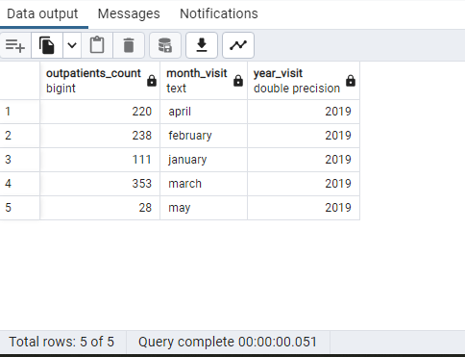

--63. Write a query to get list of patient ID's whose BloodPressureSystolic is

131,137,138--

Query:

SELECT av."Patient_ID",av."BloodPressureSystolic" FROM public."AmbulatoryVisits" as av

WHERE av."BloodPressureSystolic" in ('131','137','138');

with cte as

(

SELECT count(av."Patient_ID") counts,

to_char(av."DateofVisit",'month')month_visit,date_part('year',av."DateofVisit")yrs,

'outpatients' type

FROM public."AmbulatoryVisits" av

GROUP BY month_visit,yrs

UNION ALL

SELECT count(rr."Patient_ID") counts,

to_char(rr."AdmissionDate",'month') month_visit,date_part('year',rr."AdmissionDate")yrs,

'inpatients' type

FROM public."ReAdmissionRegistry" rr

--WHERE av."Patient_ID"= rr."Patient_ID"

GROUP BY month_visit,yrs

)

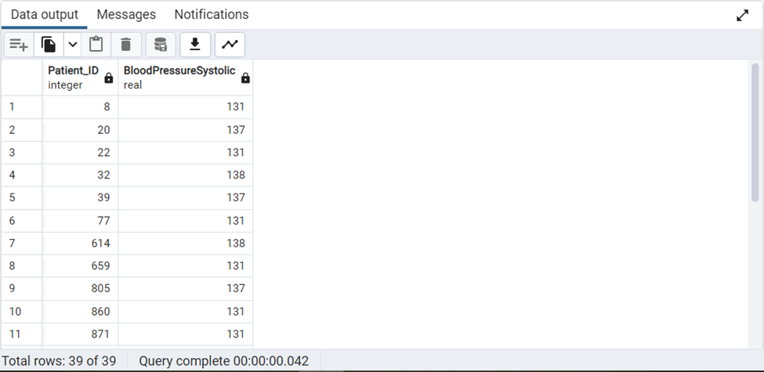

Note: Used Common Table Expression for combining 2 queries.

--64. Query to classify expected LOS into 3 categories as per the duration. (Hint:

Use of CASE statement)--

Query:

SELECT "Patient_ID","ExpectedLOS",

case

when "ExpectedLOS" <'2' then 'NormalStay'

when "ExpectedLOS" >'2' and "ExpectedLOS"<'5' then 'ShortStay'

when "ExpectedLOS" >'5' then 'LongStay'

else 'NoStay' end category

FROM public."Discharges" ORDER BY "ExpectedLOS";

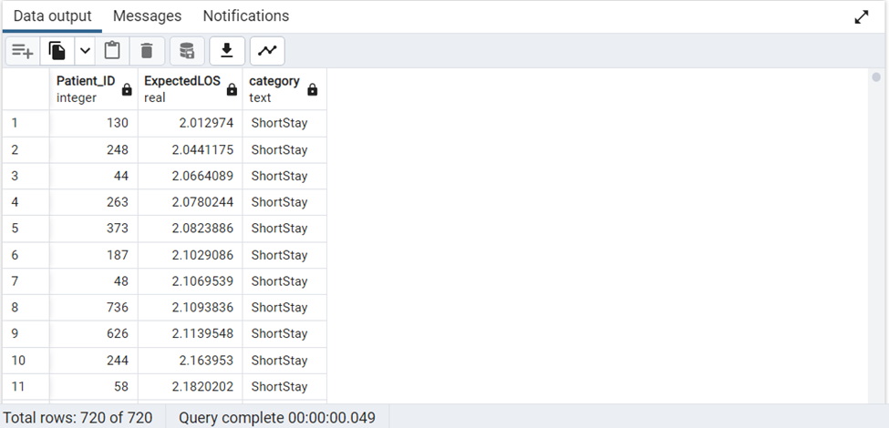

--65. Write a query to CREATE a table to list the names of patients whose date of

birth is later than 1st jan 1960.Name the table as “Persons”--

Query:

--Creating Table "Persons"

SELECT "FirstName","LastName","DateOfBirth"

into "Persons" /*Temptable*/

FROM public."Patients"

WHERE "DateOfBirth" > '1960-01-01'

ORDER BY "DateOfBirth";

--Checking Table "Persons"

SELECT * FROM "Persons"

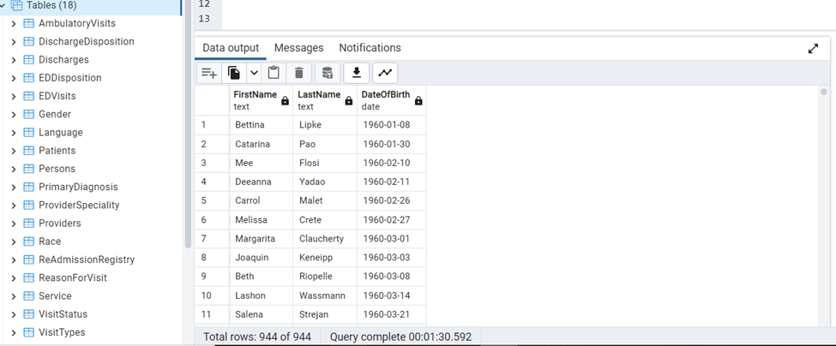

--66. Write a query to Count number of patients who has discharged after march3rd 2018

Query:

SELECT COUNT(D."Patient_ID")

FROM "Discharges" D

WHERE D."DischargeDate" > '2018-03-03 23:59:59'

--67. Replace ICU with emergency (Hint: Do not update or alter the table)—

Query:

SELECT S."Service" ,

REPLACE(S."Service", 'ICU','Emergency') AS New_Column

FROM "Service" S

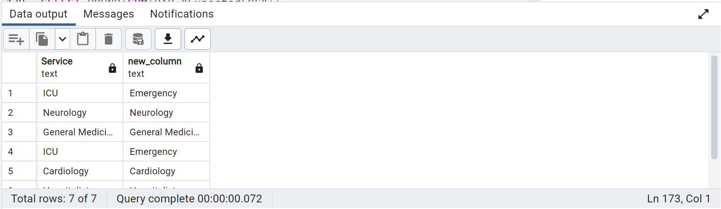

--68. Write a query to get Sum of ExpectedLOS for Service_ID 'SID01'—

Query:

SELECT SUM("ExpectedLOS") AS ExpectedLOS_Sum

FROM "ReAdmissionRegistry"

WHERE "Service_ID" = 'SID01'

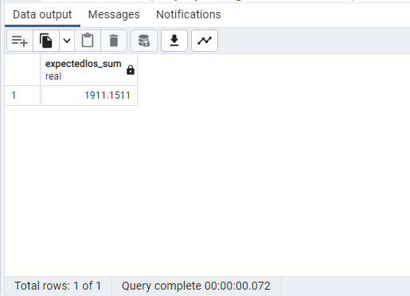

--69. Create index ONtable Provider by selecting a column and filter by using WHERE condition

Query:

CREATE INDEX psid_idx

ON "Providers"("PS_ID")

WHERE "ProviderDateOnStaff" > '1999-12-31'

--70. List down all triggers in our HealthDB database

Query:

SELECT event_object_table AS table_name,trigger_name

FROM information_schema.triggers

GROUP BY table_name,trigger_name

ORDER BY table_name,trigger_name

-- 71. Partition the table according to Service_ID and use windows function to calculate percent rank. Order by ExpectedLOS

Query :

SELECT "Service_ID","ExpectedLOS",PERCENT_RANK() OVER ( PARTITION BY "Service_ID" ORDER BY "ExpectedLOS") AS Percent FROM "Discharges"

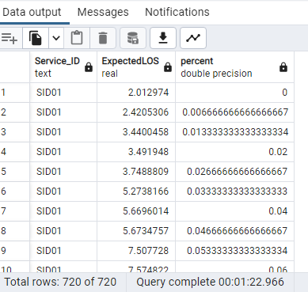

-- 72. Write a query by using commONtable expressions and case statements to display birthyear ranges

Query :

WITH DOBYears AS

(

Select

"Patient_ID",

"DateOfBirth",

EXTRACT('Year' FROM "DateOfBirth") AS DOBYear

FROM public."Patients"

)

SELECT "Patient_ID", "DateOfBirth",

CASE

WHEN DOBYear BETWEEN 1960 AND 1969 THEN '1960s'

WHEN DOBYear BETWEEN 1970 AND 1979 THEN '1970s'

WHEN DOBYear BETWEEN 1980 AND 1989 THEN '1980s'

END AS "Birth_Year Ranges"

FROM DOBYears ORDER BY "DateOfBirth" ASC

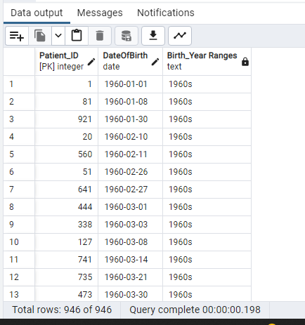

-- 73. Get list of Provider names whose ProviderSpeciality is Surgery

Query :

SELECT "ProviderName" , "ProviderSpeciality" FROM "Providers" P JOIN "ProviderSpeciality" PS

ON PS."PS_ID" = P."PS_ID" WHERE PS."ProviderSpeciality" = 'Surgery'

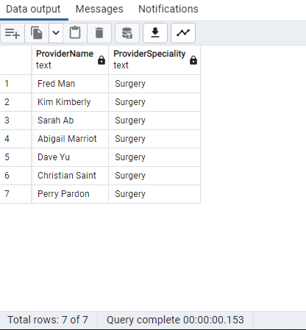

-- 74. List of patient FROM rows 11-20 without using WHERE condition.

Query :

SELECT "Patient_ID","FirstName","LastName" FROM "Patients" ORDER BY "Patient_ID" LIMIT 10 OFFSET 10

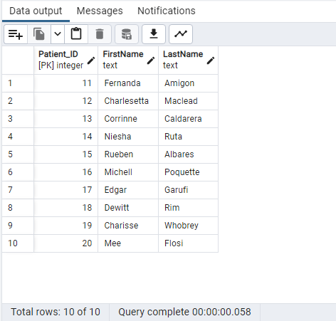

-- 75. Give a query how to find triggers FROM table AmbulatoryVisits

Query:

SELECT event_object_table AS table_name ,trigger_name

FROM information_schema.triggers

WHERE event_object_table ='AmbulatoryVisits'

GROUP BY table_name , trigger_name

ORDER BY table_name ,trigger_name

-- Q76:Recreate the below expected output using Substring.*/

Query :

SELECT "Gender" , substring("Gender",1,1) as "gender" FROM "Gender"

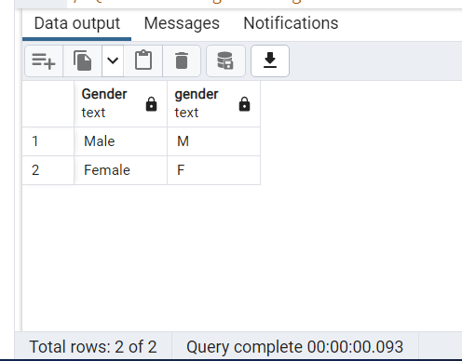

/* Q77: Obtain the below output by grouping the patients.*/

Query:

SELECT "Patient_ID"

,"FirstName"

,substring("FirstName",1,1) as "patient_group"

FROM "Patients"

WHERE "FirstName" Like 'L%'

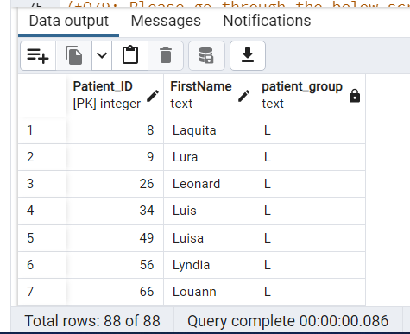

--Q78: Please go through the below screenshot and CREATE the exact output.*/

Query:

SELECT "FirstName"

,length("FirstName") as unknown

FROM "Patients"

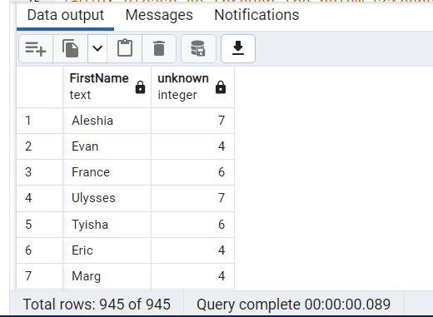

--Q79: Please go through the below screenshot and CREATE the exact output */

Query:

SELECT "BloodPressureDiastolic","Pulse"

, ceil("BloodPressureDiastolic") as "bpd"

, Floor("Pulse") as "heartrate" FROM "AmbulatoryVisits" offset 1 Limit 21

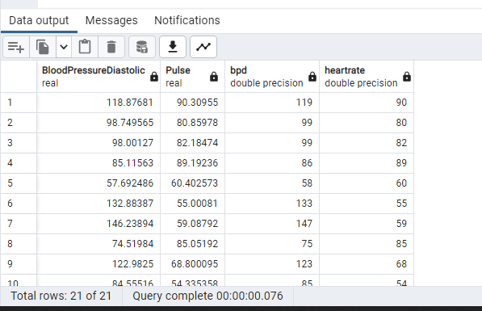

--Q80: Please go through the below screenshot and CREATE the exact output */

Query:

SELECT "BloodPressureSystolic"

, 'The Systolic Blood Pressure is ' || round(cast("BloodPressureSystolic" as Decimal),2) as "Message"

FROM "AmbulatoryVisits"

